D3.3 Annexure
(this document is licensed under CC-BY-4.0)

Table of Contents

Requirements Analysis 3
Sources for requirements 3
T2.3 | Requirements for design reuse 3
DIN SPEC 3105-1 | Requirements for Technical Documentation of Open Source Hardware 4
D3.1 | User stories 4
OKH | OSH Metadata Specification 6
Results 8
For the LOSH System 8
Modular System Design 8
Data input via APIs 9
Data Pre-Processing in Krawler 10
Make Data Available via Frontend, Wikibase and RDF 10
Reconciliation API for Wikibase 11
For the OKH-LOSH Specification and Ontology 12
General Specifications 12
Metadata Block 1: Minimum Information 13
Metadata Block 2: Further Data Required by User Stories 13
Metadata Block 3: Production Metadata 14
Raw Data 15
LOSH as a Service 16
LOSH as a Reusable System 17
RDF2WB-Converter 18
Design notes 18
Installation 18
Step-By-Step Example 19
LOSH-Frontend 20
Development Method 20
Design Notes 20
Installation 23
References 24

Requirements Analysis

Sources for requirements

T2.3 | Requirements for design reuse
T2.3 “Facilitating Documentation for design reuse” investigated high-level criteria that would enable and facilitate design reuse in the domain of OSH [1]. The following tablexxx presents extracted key findings with resulting conclusions made for LOSH.

N° | Key Finding | Conclusion for LOSH
1 | The product model is represented by essential documents and other files constituting the “source code” of an OSH product. Those files come in different formats (e.g. CAD data in digital exchange formats (like STEP, STL) or proprietary geometric formats (as from CATIA or SolidWorks)) and their necessity and usefulness highly depend on the technology of the product model. | Metadata will represent product models.  Source files are essential and should be referenceable.  The model should work for a large variety of technologies.  Available source files should be a prerequisite for a product model to be listed on LOSH.
2 | Modularity is a key concept in OSH. Sub-elements can be substituted, modified and remixed among different products from independent developers. | Results on LOSH shall be seen as modules rather than complete products.  LOSH should allow searching and comparing modules from different online platforms.
3 | Design rationales are great for design reuse, but it seems relatively poorly implemented in practice. The format (including file format and modelling language) used can have a significant impact. | Support the use of design rationales in open formats (such as UML), but don’t expect it.  Require at least a functional description per module so that the intention of a design is clear.
4 | Consistent product data management (PDM) is an important factor for design reuse, especially for an industrial context. | Consistent versioning is key (especially for remixing): Modules (see point 2 in this table) must be unambiguously referenced.
5 | Semantic modelling of product information enables a much wider and complex retrieval system. Since all data in that context is open source, exploration, reuse and linking of information can support new, thriving use cases and scale the positive effects of design reuse. However, this concept seems barely integrated in practice. | Ontology should be as compatible as possible to existent relevant ontologies and enable modular expansion.  Also data on LOSH shall be referenceable, exploitable and platform-independent.  Hence both, ontology and data shall be available as RDF.
6 | Fundamental requirements for design reuse are stated in DIN SPEC 3105-1 and can be broken down into specific goals. In any case, incomplete design documentation was identified as one of the most influential factors inhibiting design reuse. | Get further requirements from DIN SPEC 3105-1.  Classify documentation completeness.  Aim for OSH with high-quality documentation.

The design of the LOSH system and the OKH-LOSH metadata specification reflect these conclusions.
As from point 6 of tablexxx, DIN SPEC 3105-1 was used to raise more specific requirements on which technical documentation qualifies to be listed on LOSH.

DIN SPEC 3105-1 | Requirements for Technical Documentation of Open Source Hardware
DIN SPEC 3105-1 features the first official standard for open source hardware, published in July 2020 under a free/open license [2]. According to the standard, technical documentation qualifies hardware as open source hardware when:
- “has been released under licensing terms complying with the OSHWA Definition 1.0 [3] […] and therewith granting anyone with the four rights of open source hardware;
- [it] provides enough information to enable recipients to exercise these rights” [4].

Hence “Documentation of a piece of OSH bears references of:
- “its authors;
- its licensing terms;
- a functional description of the piece of OSH,
e.g. what functions it is supposed to deliver, what is the problem it solves, for whom, etc.;
- a mention of all applying Technology-specific Documentation Criteria;
- all documents required by the mentioned Technology-specific Documentation Criteria;
- a name or working title given to the Piece of Hardware” [4].

The technical documentation itself must be published on the Internet in the original editable file format and an export file format [4].

D3.1 | User stories
The D3.1 deliverable identified specific needs in the form of target-group-specific user stories. These were sorted into needs that would be
- directly (e.g. by a specific feature),
- indirectly (that is, supported, but not fully covered) or
- not addressable
by LOSH. From 80 user stories, 33 have been identified to be coverable either directly or indirectly, as shown in figxxx.
Addressable user stories have been separated by their perspective. As visualised in figxxx, “Community” and “Project Owner” make up 80,9 % of the overall perspective on addressable user stories (90 % of directly and 74 % of indirectly addressable user stories). Hence community members, specifically project owners and contributors (e.g. from fablabs and SMEs), were identified as the main target group for solutions in T3.3 and T3.4.
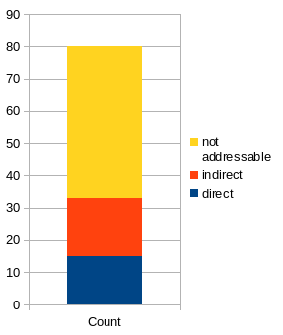
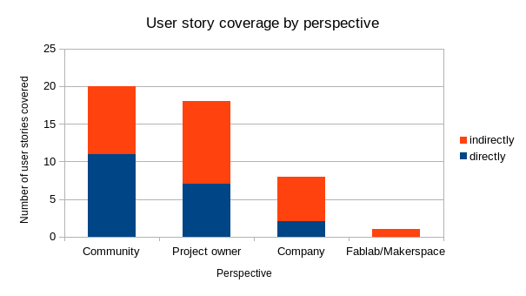
All direct addressable user stories have been covered by LOSH, all indirectly covered user stories have been considered in the design of LOSH. The following list concludes the requirements raised from addressable user stories. For details, e.g. comments and conclusions on each user story, please see the references to the raw data in ch. xxx.

Concluded requirements for LOSH from D3.1 user stories:
- Metadata shall represent modules rather than complete products.
- The specification shall be applicable platform-independent.
- All information hosted or referred on LOSH shall be available under a free/open license – specifically OSH designs.
- Consistent versioning shall be enforced as a mandatory requirement in the specification.
- The following metadata fields shall be included in the specification:
  - `standard-compliance` (reference to technical standards followed in the design),
  - `functional-description` (short description of what the module does, which problem it solves for whom),
  - references to essential files (including source & export files, manufacturing instructions, user manual, bill of materials, contribution guide),
  - `file-format` (to allow conclusions on compatible software to edit referenced files),
  - `tsdc-id` (to refer to community-based documentation standards),
  - `release`(to refer to downloadable bundles of a specific version).
- The specification shall include production-related metadata for improved filtering in technology research and to facilitate matchmaking with potential manufacturers.
- The specification shall include an intuitive classification system for technology and documentation maturity, including its CE-certification status (see OTRL/ODRL from the former deliverable D3.2 “Developing the platform features”).
- All metadata containing measures shall rely on SI units.
- Metadata should be kept lean; avoid irrelevant data.
- LOSH should provide a compact view of relevant information for each module, also to facilitate the comparison of different solutions.
- LOSH data and the specification should be available as Linked Open Data at a low threshold, thus as RDF. That way also other knowledge bases may be linked with LOSH data.
- LOSH should provide guidance on how to share OSH designs efficiently.

OKH | OSH Metadata Specification
As known from ongoing standardisation efforts in the field of open source hardware there is already a promising approach to organise OSH designs across the Internet via standardised, representative metadata [2]: the Open Know-How Manifest Specification Version 1.0 [5].

The specification states that metadata shall be provided in manifest files with a standard file name and standard location in repositories. Manifest files are plain text YAML files, so:
- they are both, human- and machine-readable;
- creation, studying and modification does not require special computer skills;
- they can be implemented and used by OSH online platforms with relative ease.

This makes them very attractive for the use case of LOSH, as for instance a crawler would be able to find and process manifest files automatically.
However, there have been extensive discussions on the data format [6]. The team consulted maintainers of the specification, which recommended TOML or JSON as potential future formats.

Since the specification is already in use since 2019 [2], the team could analyse usage data of the OSH community: from the official OKH repository those were 392 manifest files [7], each representing an OSH module. Figxxx visualises the distribution usage of metadata fields among those manifest files and figxxx shows a detailed view for the top 87% metadata fields most used. The raw data of this analysis is referenced in ch.xxx. The tool developed for this analysis has been published under a free/open license [8].

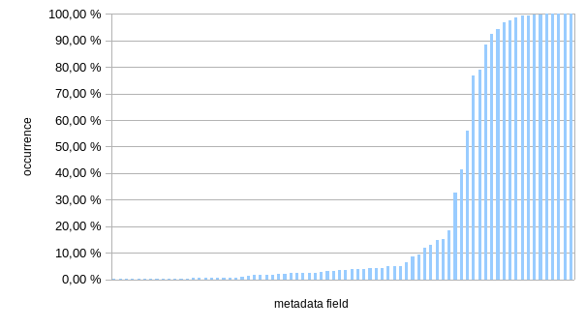

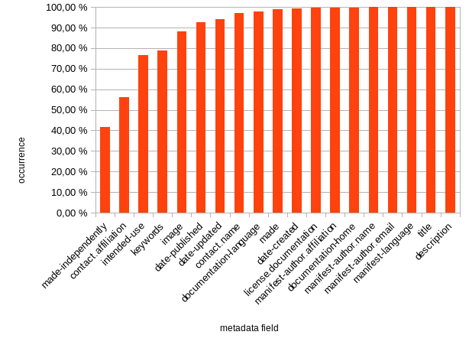
Key findings from the analysis:
- Most frequently used data fields highly correlate with requirements from DIN SPEC 3105-1, but
- Some fields that appear crucial for the intended use of the specification, but are not defined as mandatory, have not been consistently used in practice.
- Appropedia, which created 92% of all manifest files, already forked and extended the specification.
- Some fields include personal data which raises a potential risk of violations of GDPR, keeping in mind that the information is published under licensing terms that allow for free redistribution and remixing.

The full specification has been reviewed, all defined data fields have been assessed according to their usefulness to meet requirements from the preliminary findings of T2.3 (including the requirements stated in DIN SPEC 3105-1) and from the user stories of D3.1.

Results

For the LOSH System
The following conclusions have been drawn from the LOSH system from the previous analysis of requirements. Some affect solutions of the coming deliverable D3.4 “Data collection” and will be considered there.

Modular System Design
Especially for complex projects, modularity is a key best practice for FOSS [9]. Applied to LOSH, this would bring various benefits, mainly:

- better exploitability:
  - remixing, adding and substituting modules allows for application in more (and potentially also more complex) use cases of the whole system;
  - individual modules (or bundles) can be reused in totally different environments;
- better maintainability:
  - easier troubleshooting (errors can be assigned to a specific module);
  - less complexity per module;
  - possible substitution of problematic modules in case of recurring errors;
- more flexibility;
  - scope of LOSH can be extended by adding/substituting modules;
  - connection to other systems (e.g. other knowledge bases) are possible at a low threshold.

Examples:
- Projects with no relation to OSH, could use the Krawler, WikibaseReconcileEdit and Wikibase to organise any other data available from APIs as Linked Open Data.
- RDF2WB can ease the process of setting up any Wikibase instance with an already defined ontology (e.g. CPC) without any other module required from LOSH (apart from Wikibase itself)
- If future maintainers (specifically Open Source Ecology Germany e.V.) decide to move away from Wikibase, this would be easily possible by replacing Wikibase and WikibaseReconcileEdit by any other suitable RDF framework (such as Apache Jena).
- Integrating the OSH-Repository-Checker so that an in-depth quality check of a OSH repository is performed before data is processed by the Krawler could lead to an improvement of data quality on LOSH. The OSH-Repository-Checker could also be integrated into the Dashboard (T2.2 “Creating a design process facilitation dashboard”) once this would also load data directly from git-based repositories. Also the dashboard itself could be integrated into the LOSH frontend, allowing for analyses of all git-based OSH projects.

Data input via APIs
Data shall come from various sources. Relying on manually written information only, as the OKH approach [2], may lead to inconsistent use of the specification (e.g. typos or the introduction of new data fields). Furthermore, besides a wide representation of OSH communities in the creation of that specification [5] only a fraction of projects from those OSH communities provided manifest files more than a year later [7]. That indicates a low motivation of communities to take the extra effort to provide project metadata, even though an online form exists [10] taking off the burden of hardcoding manifest files themselves.
This becomes specifically understandable for projects hosted or referenced on online platforms that already provide project metadata via their API (such as Wikifactory or the List of OSHWA-certified OSH products).
On the other side, relying on HTML scraping, as classical crawling does, may also lead to incomplete, inconsistent and faulty data sets (as seen in the former D3.2 “Developing the platform features”, chapter “Identifying production metadata in documentation through machine learning”), since there is little control on what specific HTML source code is effectively analysed by a crawler.
In consequence the Krawler could load data from online platforms for which 1) a publicly accessible API, providing relevant metadata is available and b) a data mapping between their data structure and the OKH-LOSH specification has been created.
The design of OKH-LOSH allows for an integration of the specification into the data structure and API of a willing online platform at a low threshold, so that more complete datasets may become available from already integrated APIs in the future.

Data Pre-Processing in Krawler
Since data shall come from different platform APIs and it is expected that each API will follow an individual data structure, data must be mapped onto the desired target structure (“normalised”) at some point. As it was found that OSH projects come with very distinct documentation maturities, it is reasonable to raise certain quality criteria data sets need to pass.

For instance, a test crawl, performed on the Wikifactory API on May 6th 2021 reported 3990 projects available on Wikifactory, of which
- 3,523 had no mention of a license;
- 2,554 had no image;
- 36 had a license not matching with any free/open license on the SPDX license list.
Crawled data is referenced as raw data in ch. xxx.

To provide users with uniformly structured data at a reasonable quality level, this must happen inside the Krawler as the RDF export is created before uploading data to Wikibase. For the first release of LOSH only basic requirements from the OSHWA definition [3] and DIN SPEC 3105-1 [4] will be enforced for the quality check.
For the first release of LOSH, metadata of an OSH module must bear reference of:
- the complete legal information (name, license, licensor);
- an unambiguous reference to its repository, where source files are available;
- its specific version;
- the language in which the documentation is written;
- its functional description.
By that, all information on LOSH refers to freely exploitable OSH designs only, taking off the risk for users to run into legal issues related to the infringement of licensing terms.

Make Data Available via Frontend, Wikibase and RDF
User stories pointed out different levels of potential exploitation of data hosted on LOSH. The dataflow was designed accordingly so that exploitation is enabled on three distinct levels covering different use cases for different target groups:

- Explore via Frontend
The primary target groups (“Community” and “Project Owner”, e.g. from SMEs and Fablabs) are not expected to come with significant knowledge about Linked Open Data, RDF or Wikibase. Thus a frontend shall provide these target groups with an intuitive interface to search and filter data on LOSH with no extra training or necessary special knowledge. However, data exploration via such a frontend is naturally limited to specifically developed features on that frontend.
- Direct Wikibase Access
Wikibase features the backend for LOSH, holding all data displayed on the Frontend. Users can submit highly customisable queries to the knowledge base via a publicly available query service. This allows for answering more complex questions, such as: “Which is the most popular online platform to host technical documentation of OSH ventilator designs?”. Results can be downloaded in various different formats, e.g. JSON or CSV. The service relies on SPARQL, an RDF query language. To use the service, users must be able to formulate their question in SPARQL.
- Raw RDF
To unlock the full potential of data collected by the Krawler, users may refer to the raw RDF export of it. Data can be linked, queried and integrated into other systems, without limitations from the Wikibase framework. This is particularly useful for online platforms that want to host (parts of) data collected by the Krawler since data is available in it’s raw format and does not need to be mapped starting from a Wikibase export. The format is therefore also feasible for further research on OSH data.
Besides that, having data available as RDF removes the dependency on Wikibase for LOSH, making the whole system more modular and resilient to possible changes.

For the OKH-LOSH Specification and Ontology

General Specifications
To support portability, the manifest file approach from the OKH specification will be taken. Metadata thus can be provided by structured plain text files (“manifest files”), which are found by the Krawler. For better searchability a naming and location convention of those files have been defined in the OKH-LOSH specification. For better human-readability and improved safety, the TOML format has been chosen, based on a discussion in the OKH community [6].

As LOSH shall get data from different online platforms, a platform-specific mapping is required per platform. Full compliance with the specification will be possible with manifest files, which are yet based on manual input.

OSH developers are the primary source creating representative metadata for OSH modules. Since manual input of metadata is an extra effort for OSH developers that does not contribute directly to the functionality of the module, the motivation to do so may be low. While this may change once the specification reaches wide adoption and practical benefits of following the specification become clearer, the point has become visible in the first two years of practical adoption of the OKH specification (see ch. xxx) and confirmed in pre-validation workshops within the OPEN!NEXT consortium (see ch. xxx). In consequence, the specification aims to add as little extra effort as possible for this target group.

To keep the specification easily readable and applicable in practice, informative data fields shall be avoided if they don’t contribute directly to the scope of LOSH (improved discoverability and faster comparability of OSH modules to support design reuse of these). Custom data fields will not be processed by the Krawler and hence not integrated in the LOSH knowledge base. However, due to the flexible structure of LOSH, specification and ontology are extendable anytime if needed.

As a best practice, to reduce maintenance and for improved portability, where possible, the ontology, which is the machine-readable version of the specification, shall refer to already existing ontologies. For instance, instead of maintaining an own list of free/open licenses, the ontology shall refer to SPDX, an established project by the Linux Foundation for Software Data Package Exchange specifications, also actively maintaining a list of licenses endorsed by the Free Software Foundation and the Open Source Initiative. From the metadata perspective, licenses thereby become referenceable directly by their SPDX-Identifier, which also facilitates the data quality check for the Krawler.

To support portability and wide adoption of the specification, it shall be both human- and machine-readable; the following core documents have been provided:

- OKH-LOSH specification in Markdown format (URL);
- OKH-LOSH ontology in RDF/TTL format (URL);
- manifest file template (URL) and example (URL) in TOML format;
- processed manifest file example as RDF/TTL (URL).

All files related to the OKH-LOSH specification have been made publicly available in a GitHub repository under a free/open license, allowing for free exploitability,

Metadata Block 1: Minimum Information
To grant anyone with the “right to study, modify, make and distribute”, as outlined in the OSHWA definition [3] and DIN SPEC 3105-1 [4] and in the previous ch. xxx, the specification shall include at least the following information:

- unambiguous reference of the technical documentation (e.g. working title, version, release, repository)
- mandatory legal information (e.g. authors, licensing terms)
- essential descriptions (e.g. functional description, field of technology)
- essential files (e.g. source files, bill of materials)
- the language in which the documentation is written.

The provision of mandatory legal information would demonstrate that the right to study, modify, make and distribute is granted for the published documentation. An unambiguous reference to the technical documentation is a prerequisite.
Once at least essential files are available, those rights become practically executable; essential descriptions help profiling the represented hardware so that users know what they can expect of the solution before studying the technical documentation.
With the above stated information given, users have a certain evidence that:
- the OSH solution exists and may solve their problem (judging form the functional description and the field of technology);
- that the right to study, modify, make and distribute is granted (by the use of free/open license) and can be executed (since essential files are available).

Metadata Block 2: Further Data Required by User Stories
All metadata fields that directly address needs raised in user stories, as detailed in ch. xxx, have been added.
To search OSH modules for their technology- and documentation readiness, the concept of “Open Technology Readiness Levels” and “Open Documentation Readiness Levels” have been developed in the former deliverable D3.2 “Developing the platform features”. The corresponding ontology module has been integrated so that this classification is now usable on LOSH. This is so that OKH-LOSH allows for a specification of both levels.

Metadata Block 3: Production Metadata
As requested from the user stories, a section for production-specific metadata has been developed in the former deliverable D3.2 “Developing the platform features” together with makers from within and outside the OPEN!NEXT project. These have been integrated into the OKH-LOSH ontology.

Raw Data
The raw data of the analyses is available in the subdirectory “raw data” – either in the submitted bundle of the report or in the public GitHub repository of this report.

References to file locations are shown in table xxx.

Content | File Path
Analysis of T3.1 user stories | user-stories-t3-1-analysis.ods
Raw data from crawl of OKH manifest files | OKHv1 Test Crawl/okhv1_data-field-usage-log
Quantitative analysis of data from crawl of OKH manifest files | OKHv1 Test Crawl/OKH-analysis.ods
Metadata from Wikifactory test crawl, sorted into  - total (all results)  - no-license (results with no license)  - bad-license (results with ambiguous license reference)  - no-image (results without image) | WIF Test Crawl/…

RDF2WB-Converter

Design notes
The RDF2BW-Converter consists of two parts:
- wikibase.py - containing low-level Wikibase-API-related functionality – basically a Python wrapper for the parts of the Wikibase API the converter is aiming to use;
- rdfont2wb.py - the main code, uploading a selected ontology, written in RDF, to a Wikibase instance through a selected API, while preserving the LOD logic of the ontology; in its current version it is preconfigured to upload the latest version of the OKH-LOSH ontology to LOSH’s Wikibase instance.

This functionality requires a mapping of properties from RDF to Wikibase. A variety of high-level properties have been included in this mapping to make the tool applicable for use cases beyond the domain of OSH. The mapping was done manually, scanning Wikidata for best fitting quasi-equivalents. For instance the following line in the code maps the property “version” from the OKH-LOSH ontology (which itself is connected to the “version” property from the schema ontology) to the “software version identifier” property (P348) from Wikidata:

self.create_subst_property(SCHEMA.version, 'P348', 'version',
'string') # https://www.wikidata.org/wiki/Property:P348

The python wrapper for Wikibase, wikibase.py, works without the rest of the RDF2WB-Converter and becomes particularly useful for others using the Wikibase API from a Python environment.

The main code:

- downloads the latest OKH RDF ontology from https://github.com/OPEN-NEXT/OKH-LOSH/blob/master/OKH-LOSH.ttl, or alternatively uses an already locally available file with the same name
- Parses that ontology using an RDF library
- For each RDF item, creates a JSON structure that adds a WikiBase item or property,
And sends it to api.php; thus adding the item there

Installation
From the command line:
- clone the corresponding GitHub repository
git clone git@github.com:OPEN-NEXT/OKH-LOSH-Ontology-RDF2WB.git
- install the python dependencies:
sudo pip install -r requirements.txt
- tool is executable

Step-By-Step Example
After installation, as described in the previous section, the tool is executable from the command line:
You may just run the tool with your username and password for WikiBase:

./rdfont2wb.py UserName Password

The tool will:
- download the latest OKH RDF ontology from https://github.com/OPEN-NEXT/OKH-LOSH/blob/master/OKH-LOSH.ttl, or alternatively uses an already locally available file with the same name;
- parse that ontology using an RDF library;
- create a suitable JSON structure for each RDF item to add a Wikibase item or property;
- submits the results to api.php, thus adding the item to the target Wikibase instance (losh.ose-germany.de).

If the execution is successful, the resulting log will look similar to this:

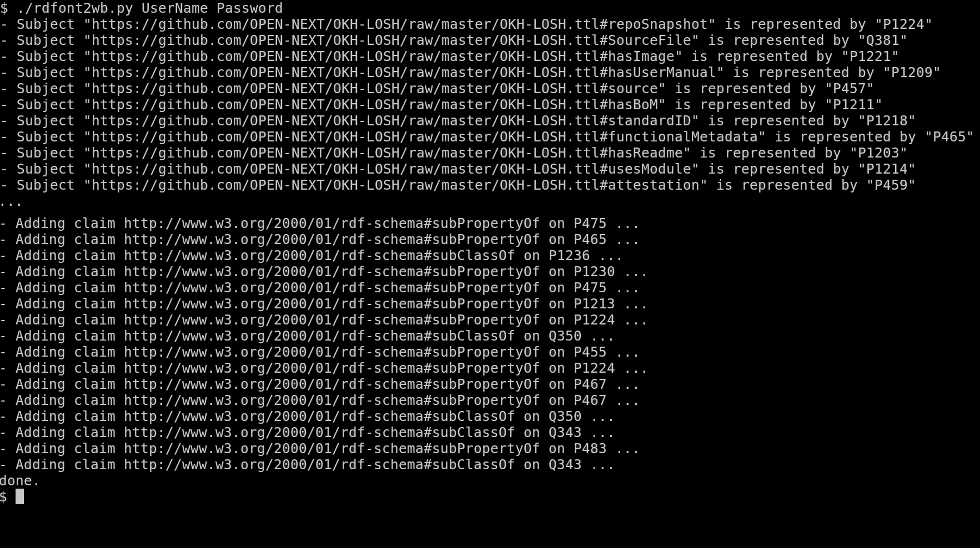

LOSH-Frontend

Development Method
The team applied agile development processes in working on the LOSH-Frontend. After concluding an initial user experience co-creation session and coming up with a workable wireframe, the team settled on a design pattern library and iteratively improved on the designs while starting frontend development. Content was provided along with refined screen designs, incorporating feedback.
Working in bi-weekly sprint cadences, the team continuously deployed the current master of the frontend to a test platform.

Design Notes
- Collaborative ideation on information architecture of the LOSH-Frontend
- Incorporating user needs based on prior research, best practices while co-creating wireframes in Figma (please, see the Figma design below)
- Iterative development in close cooperation with the user experience designer, and implementation of the OPEN!NEXT design style.

The LOSH Frontend is built as a separate software module that can be automatically deployed utilising GitHub Actions or GitLab’s CI/CD onto a given webspace.

The following screenshots outline the figma screen designs based on the co-created Wireframes:

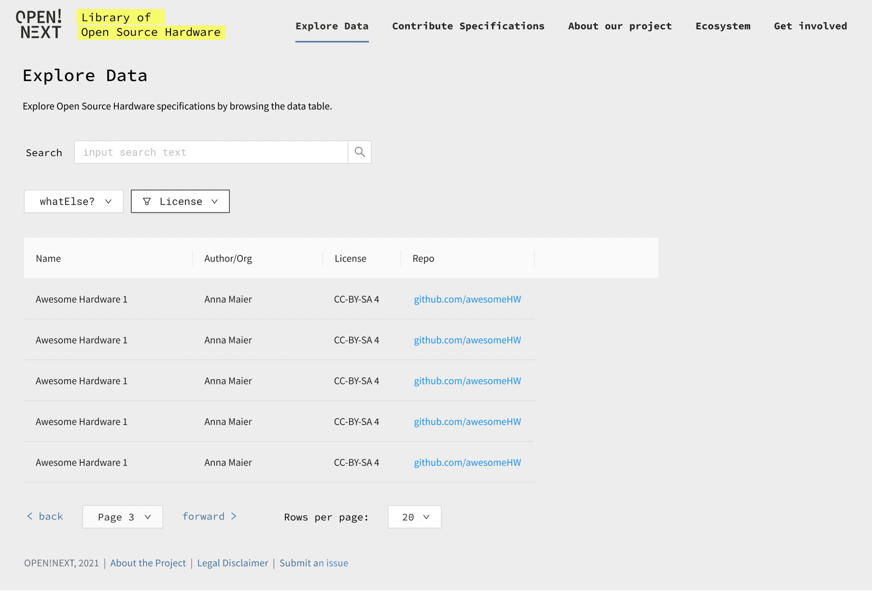
Figma Figure1.1: “Data Explorer” page design - Allowing for easy search and filter options
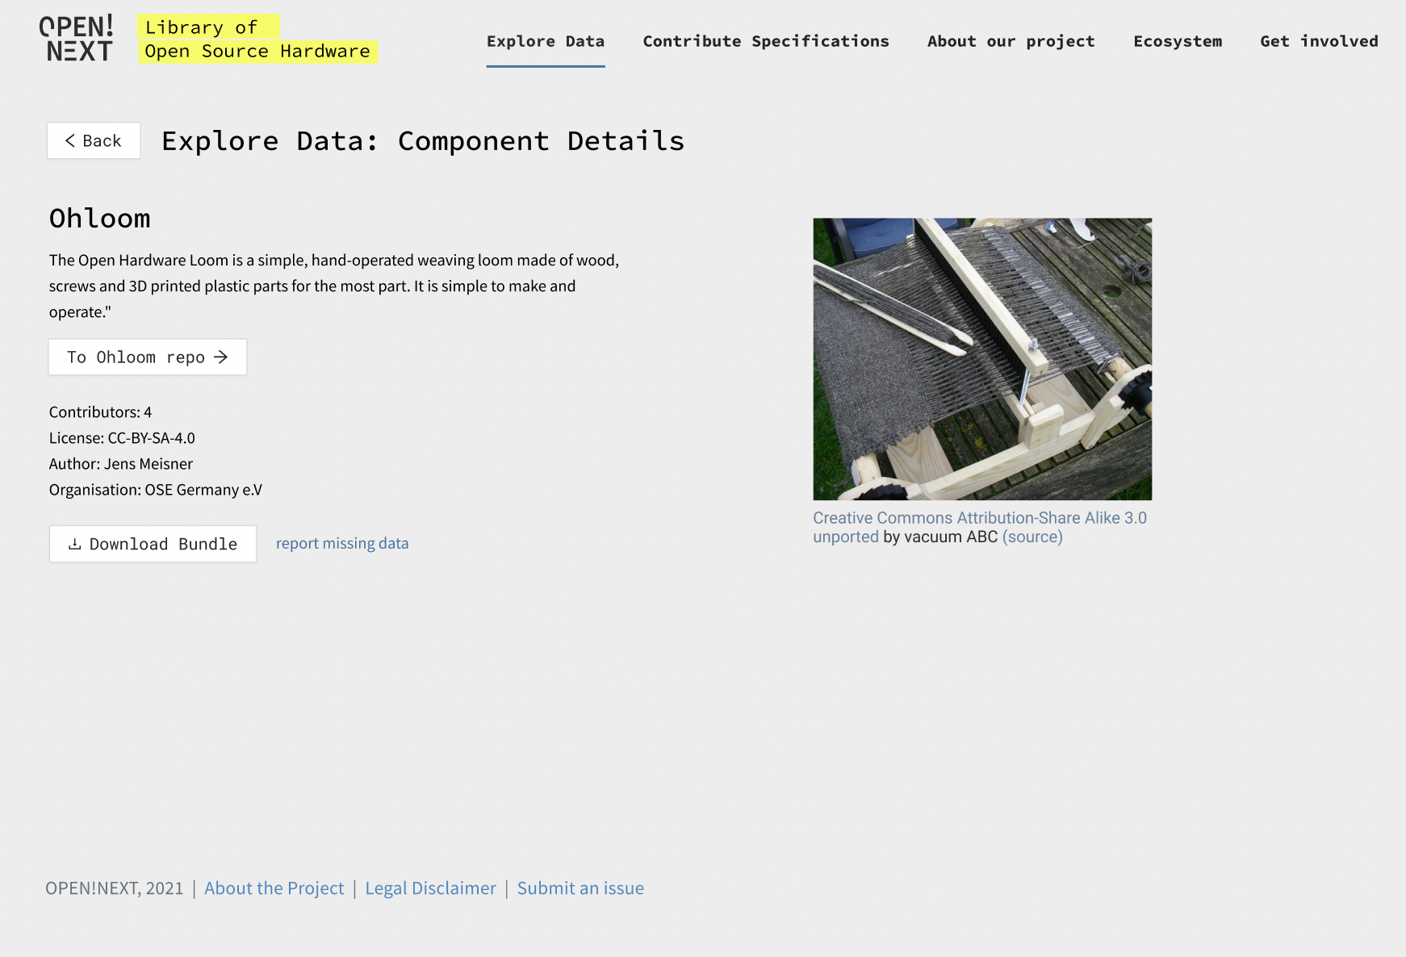
Figma Figure 1.2. “Explore Data: Component Details” page design - detailed description of the selected specification

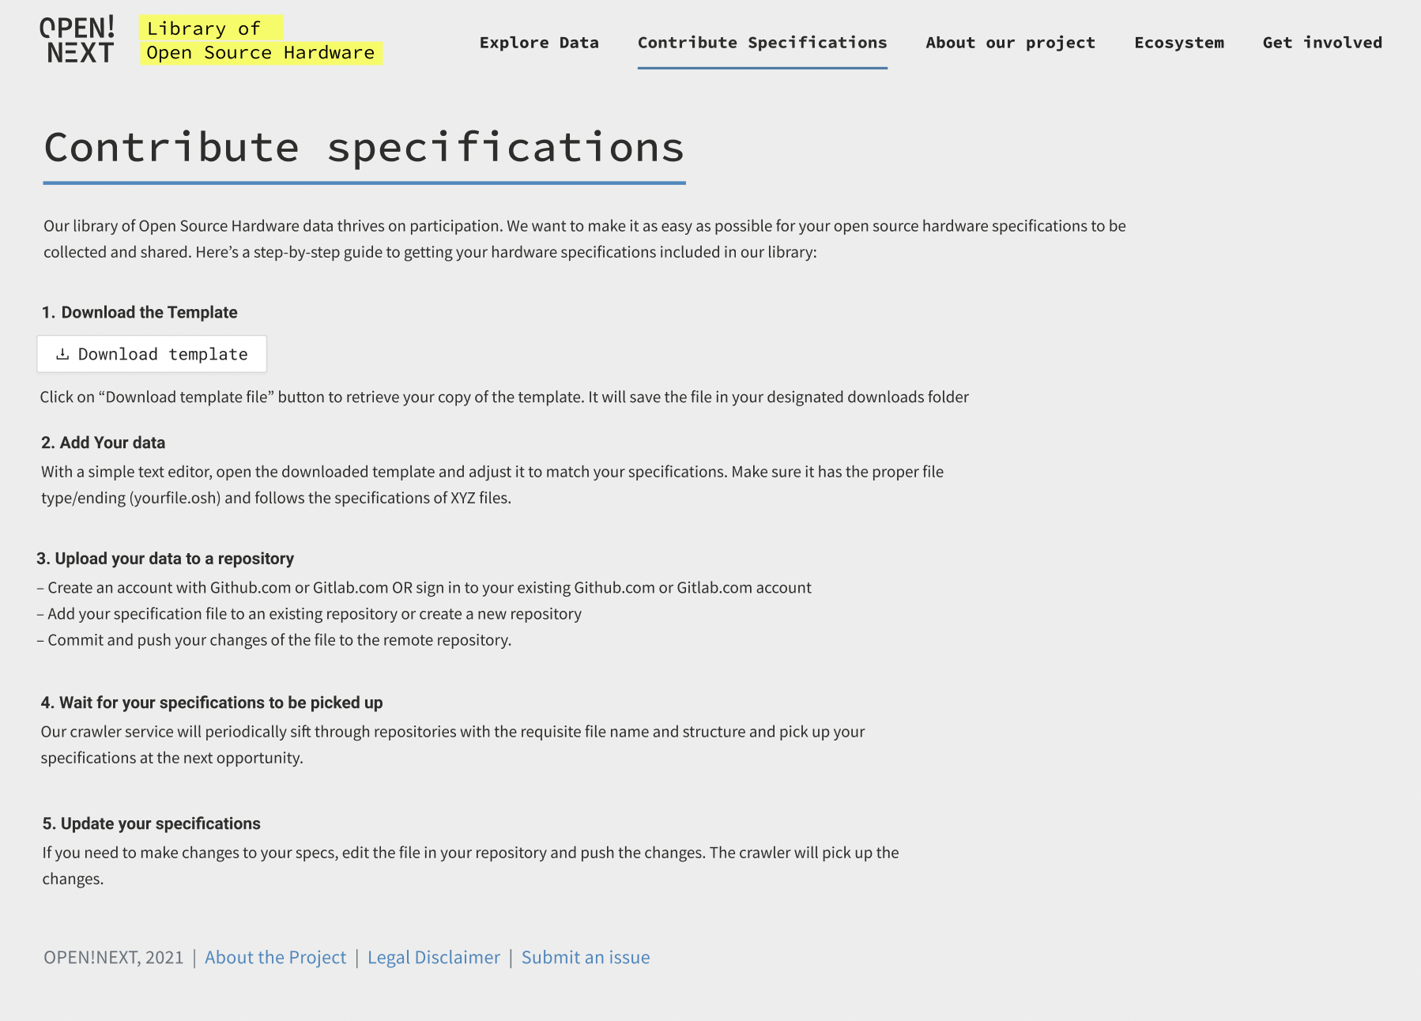
Figma Figure 2. “Contribute specifications” page design - A step-by-step guideline on how to contribute specifications to the topic

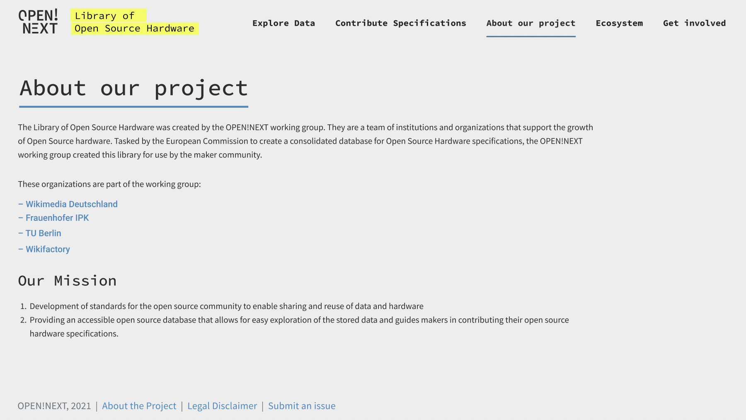
Figma Figure 3. “About our project” page design - Explaining the background of the LOSH working group and our mission

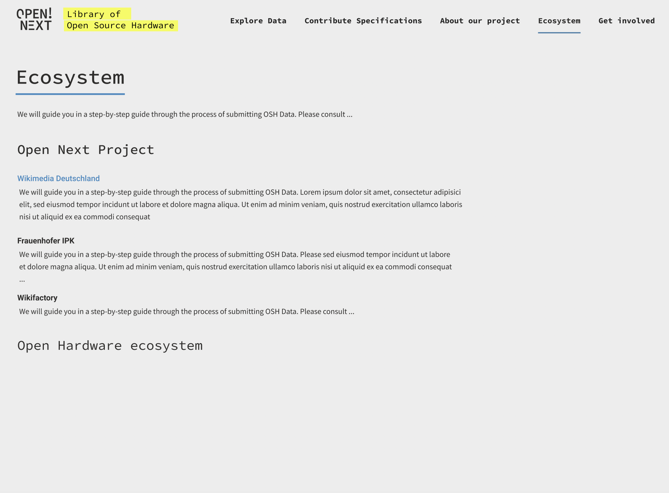
Figma Figure 4. “Ecosystem” page design - a description of the Open Source Hardware.

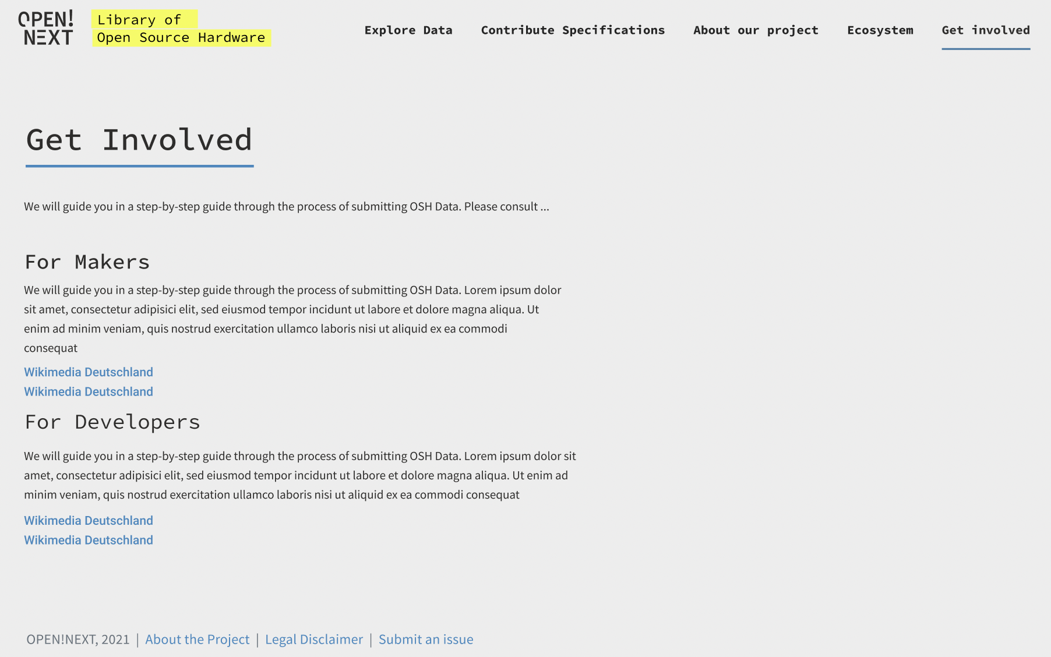
Figma Figure 5. “Get involved” page design - A page to invite people to contribute to the project

Specifications

HOME
OSH
Data Explorer
Submit OSH projects
About the Project
OSH Ecosystem
Get Involved
OSH Data Detail View
- Data explorer
  - Display compact previews of the stored OSH data in a comprehensive data table
    - Display single OSH item on a detail page
  - Provide a search input to allow for searching through OSH data points
  - Provide a filter functionality
- OSH Submission
  - Provide a guideline for OSH submission through LOSH
- About the project
  - Information about OPEN!NEXT
- OSH Ecosystem
  - Linking to related projects
- Get involved
  - Engage open source maintainers
  - Report bugs and feature requests

Summary and Outlook
Development of the frontend is carried out as a free/open source software (FOSS) project and therefor shall respect and comply with best practices from the FOSS community, specifically:
- Source code will be published under GPLv3 on a git-based online platform (e.g. GitHub)
- Documentation that allows for further development by open source maintainers
- Preference for usage of FOSS software wherever possible
- Automated Browser testing for all common modern browsers above IE11. Implement typical device breakpoints from common desktop usage to small tablet formats (e.g. between 2048px and 640px width)
- Comprehensive Error handling with information on how to report bugs
- Instructions for contributing to the repository after the OPEN!NEXT project is done
- Serving compiled, minified frontend code

The frontend application is in the process of development and testing on a small set of data collected by the Krawler. The result of the development will be moved to production and validated with the target audience during testing sessions in the frame of the WP3.

References
[1] A. Ezoji, J. F. Boujut, and R. Pinquié, ‘Requirements for design reuse in open-source hardware: a state of the art’, Procedia CIRP, vol. 100, pp. 792–797, 2021, doi: 10.1016/j.procir.2021.05.042.
[2] J. Bonvoisin, J. Molloy, M. Haeuer, and T. Wenzel, ‘Standardisation of practices in Open Source Hardware’, ArXiv200407143 Phys., Apr. 2020, Accessed: Aug. 18, 2020. [Online]. Available: http://arxiv.org/abs/2004.07143
[3] ‘OSHWA Definition (English)’, Open Source Hardware Association. https://www.oshwa.org/definition/ (accessed Mar. 20, 2021).
[4] ‘DIN SPEC 3105-1:2020-07, Open Source Hardware_- Teil_1: Anforderungen an die technische Dokumentation; Text Englisch’, Beuth Verlag GmbH. doi: 10.31030/3173063.
[5] MakerNetAlliance, ‘OpenKnowHow’, StandardsRepo. https://app.standardsrepo.com/MakerNetAlliance/OpenKnowHow (accessed Sep. 21, 2021).
[6] MakerNetAlliance, ‘OpenKnowHow - YAML discussion’, StandardsRepo. https://app.standardsrepo.com/MakerNetAlliance/OpenKnowHow (accessed Sep. 21, 2021).
[7] Open Know-How Search - List of Manifest Files 10/2020. Open Know-How, 2021. Accessed: Sep. 21, 2021. [Online]. Available: https://github.com/OpenKnowHow/okh-search/blob/b9e7301f4e00b4021fa089822983ab36236bafee/projects_okhs.csv
[8] Hoijui, OPEN-NEXT/OKH-LOSH-YAML-stats: v1.0.0. Zenodo, 2021. doi: 10.5281/ZENODO.5534241.
[9] A. Narduzzo and A. Rossi, ‘Modular Design and the Development of Complex Artifacts: Lessons from Free/Open Source Software’, p. 40.
[10] ‘OpenKnowHow - Manifest Online Form’. https://okh.makernet.org/form (accessed Sep. 23, 2021).

This is specifically important for CAD files since export formats are subject to information loss, which impedes effective design reuse – and native formats are mostly proprietary, so users cannot access the information without purchasing costly software licenses first.
As e.g. “version”, which would allow an unambiguous reference to the OSH module the manifest file is referring to or “licensor.name” which is essential legal information.
For instance all field related to the Sustainable Development Goals, as “sustainable-development-goals.SDG 08”, are not mentioned in the original specification.
As e.g. “manifest-author.affiliation”, “manifest-author.name”, “manifest-author.email”.
This is following a best practice for complex FOSS projects since for independently acting open source communities it’s easier to maintain simple modules with defined functions and limits than a large complex monolithic package.
The organisation signed a corresponding letter of intent and is already hosting the Wikibase instance for LOSH.
For instance, the project partner Wikifactory already modified its API according to preliminary versions of the OKH-LOSH specification.
Most of these cases occurred due to unambiguous license references on Wikifactory (e.g. the reference “CERN OHL” can lead to 5 different licenses on the SPDX license list). To fix this, the team reworked the platform’s license configuration and submitted it to Wikifactory for implementation.
Wikibase relies on an own implementation of RDF making RDF exports from Wikibase almost unusable for any other RDF implementation.
A recurring issue are designs published under licenses that exclude commercial use (e.g. CC-BY-NC-4.0), falsely labelled as OSH.
E.g. “CC-BY-4.0” for the Creative Commons Attribution 4.0 International License under which this document is made available.
SPDX-IDs have also been used to rework license referencing on Wikifactory, now avoiding ambiguity (e.g. the formerly used identifier “CERN” refers to five different licenses on the SPDX list).
since without this reference it would be unclear to which exact information the metadata, and hence also the legal information, is referring to
A guarantee cannot be given since data can be faulty or uncomplete and relies on input from the OSH community.
https://github.com/OPEN-NEXT/D3.3-Report/tree/main/raw%20data
which itself is connected to the “version” property from the Schema ontology

